**Kingsway Christian College**

**Maths Department**

**Course**: Math Methods unit 3

**Assessment Task**: Test 2

**Student Name**: ________________________________________________________

**Date**: 23rd & 24th March 2017

**Assessment Score**: ____________ / 50

**Year Score**: __________________

**Comments**: ________________________________________________________

___________________________________________________________________________

___________________________________________________________________________

___________________________________________________________________________

___________________________________________________________________________

___________________________________________________________________________

___________________________________________________________________________

___________________________________________________________________________

___________________________________________________________________________

**Teacher signature**: ________________________________________________________

**Parent/ Guardian signature**: _____________________________________________

**Comments**: ________________________________________________________

___________________________________________________________________________

___________________________________________________________________________

___________________________________________________________________________

___________________________________________________________________________

___________________________________________________________________________

**Math Methods Unit 3 Test 2 2017  
Differentiation**

**Resource Free Time: 30 minutes Marks: / 27**

**Only a formula sheet is allowed for this section. No calculator or notes allowed.**

**Question 1 (6 marks)**

**(a)** For what values of *c* does the polynomial 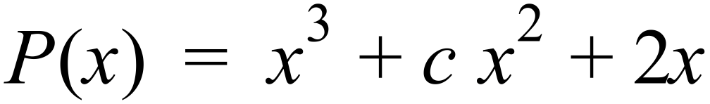 have an inflection point where *x* = 3? (3 marks)

**(b)** Sketch the graph of a function that such that: (3 marks)

* 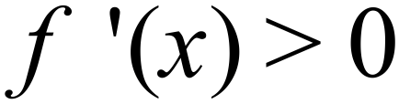 for all $x, x$ $≠1 and x≠3$
* vertical asymptote at *x* = 1
* $f\left(x\right)>0$ if $x<1 or x>3$
* $f\left(x\right)<0$ if $1<x<3$
* $f^{''}\left(3\right)=0$ and $f^{'}\left(3\right)=0$

**Question 2 (6 marks)**

Determine the maximum and minimum value for *f* (*x*) and the value of *x* at which they occur, for the function 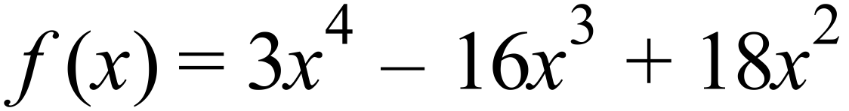 over the domain 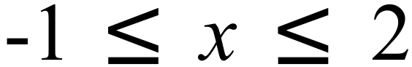 .

**Question 3 (7 marks)**

Determine the coordinates of all intercepts, stationary points and points of inflection of the function 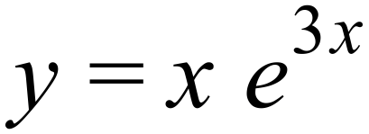.

Justify the nature of the stationary points found using a standard test.

**Question 4 (3 marks)**

Determine the equation of the normal to the curve $y=x(3-x)²$ at (2,2).

**Question 5 (5 marks)**

Find the equation of the tangent to the curve $y=2x+cos2x$ at the point ( $\frac{π}{3}$; $\frac{2π}{3}-\frac{1}{2})$

**Math Methods Unit 3 Test 2 2017 Differentiation**

**Name__________________________**

**Resource Assumed Time: 25 minutes Marks: / 23**

**CAS calculator and a formula sheet are allowed for this section**

**Question 6 (5 marks)**

A cylindrical can is to be made to hold 1 000 cm3 of oil. Find the dimensions that will minimise the amount of the metal to make the can. Assume the can is made with a lid.

**Question 7 (9 marks)**

The cost in dollars of producing $x$ items is given by: $C\left(x\right)=\left(3000+5x\right).$

The revenue per item sold is given by $ $(40-0.02x)$.

1. State the revenue function $R(x)$ for $x$ number of items sold. (1 mark)
2. Give an expression for the profit function $P(x)$. (1 mark)
3. Determine how many items are needed to make a maximum profit and state the

maximum profit. (3 marks)

1. Explain clearly if a loss occurred and when it occurred. (2 marks)
2. Determine the marginal profit of the 250th item sold. (2 marks)

**Question 8 (4 marks)**

Use derivatives to find the approximate change in the radius of a spherical balloon corresponding to a change in its volume from 200 cm3 to 195 cm3. Answer to 4 decimal places.

**Question 9 (5 marks)**

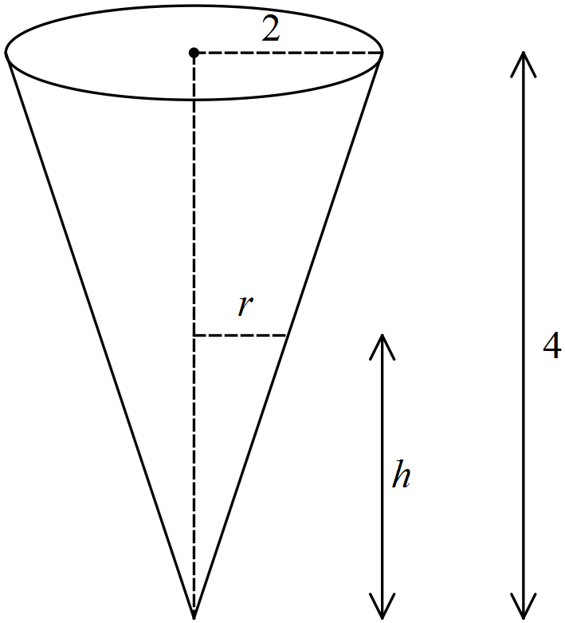A water tank has the shape of an inverted circular cone with base radius 2 m and height 4 m.

1. Proof that the volume of the tank is given by the following formula:

$V\left(h\right)= \frac{1}{12}πh^{3}$ (1 mark)

1. If water is being pumped into the tank at a rate of 2 m3/min, find the rate at which the

water level is rising when the water is 3 m deep.

Answer to the nearest cm/min. (4 marks)